For more information, contact:
Bell County Tourism
2215 Cumberland Ave / Middlesboro, KY 40965
Phone: 606-248-2482 / Email: jon@bellcountytourism.com
www.bellcountytourism.com

PARKS
Cumberland Gap National Historical Park
Location: 91 Bartlett Park Rd / Middlesboro, KY 40965
Phone: 606-248-2817
Website: https://www.nps.gov/cuga/index.htm
Come visit one of the premier national parks in the entire country in Cumberland Gap National Historical Park. You can walk in the footsteps of Daniel Boone and America’s first pioneers who discovered the first gateway to the west. The park offers over 85 miles of hiking trails, horseback riding opportunities, as well as back-country camping. Make sure to check out the Visitors Center just outside of Middlesboro, KY on Highway 25E. Also, the park has some fantastic points of interest, including the Pinnacle Overlook, the Tri-State marker, Gap Cave (tour information on park website), and Hensley Settlement (tour information on park website). 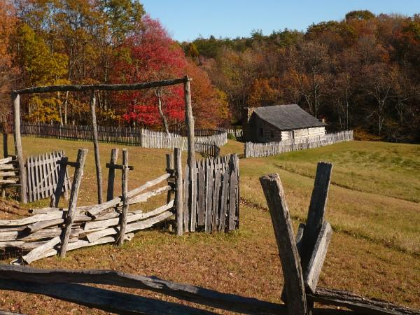
Hensley Settlement @ Cumberland Gap National Historical Park
Pine Mountain State Resort Park
Location: 1050 State Park Rd / Pineville, KY 40977
Phone: (606) 337-3066
Website: http://parks.ky.gov/parks/resortparks/pine-mountain/
Kentucky’s first state park is a hidden gem in the Commonwealth. Located just south of Pineville, KY, the park has over 15 miles of some of the finest hiking trails in all of Appalachia including favorites like Hemlock Garden Trail, Honeymoon Falls Trail, Chain Rock Trail, and much more. The park has an adjacent 18-hole golf course in Wasioto Winds, a lodge with both rooms and cabins for rent, Mountain View Restaurant, and a brand-new zip line and canopy tour. Visitors can also enjoy many fantastic overlooks, including the famed Chain Rock Overlook that overlooks Pineville (see below).
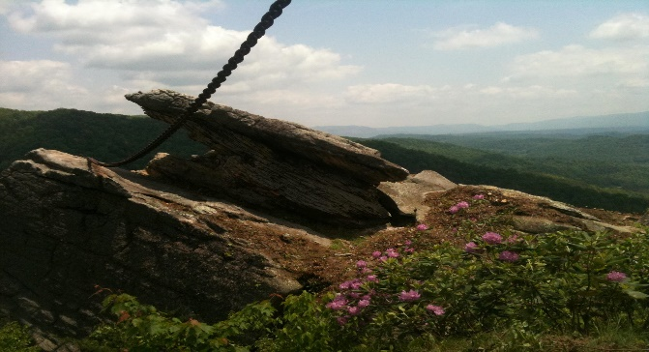
Wilderness Road State Park (Ewing, VA)
Phone: (276) 445--3065
Website: www.dcr.virginia.gov/state-parks/wilderness-road.shtml
Description: Located on US Hwy 58 in Ewing, VA, 6 miles east of the Cumberland Gap. Pioneer village with demonstrations, hiking, biking, and equestrian trails. Annual event in April is the “Raid at Martins Station” reenactment.
FISHING/HUNTING/OUTDOOR RECREATION
Cumberland River
Phone: (606) 248-2482
Website: www.bellcountytourism.com
Description: The Cumberland River runs along Hwy 119, then Hwy 25E in Pineville, and offers opportunities for both kayakers and canoers as well as anglers. Healthy populations of quality smallmouth bass exist, as well as largemouth and Kentucky bass, bluegill, walleye, and catfish. There are currently two-take outs (one under the Wilderness Trail-Off Road Park entrance bridge) which can be accessed at the Hwy 119/Hwy 987 intersection, and another near the Bell County Fairgrounds on Hwy 2014. We are currently working on finding new access points and potential take outs, so stay tuned!
Clear Creek
Phone: 606-248-2482
Website: http://www.bellcountytourism.com
Description: Offers fantastic small-water fly fishing for stocked rainbow trout (spring and fall) and smallmouth bass. The best fishing is from the Hwy 192 bridge at the Clear Creek Bible College to Wasioto Winds Golf Course. Parking area is right beside Hwy 192 near the bridge.
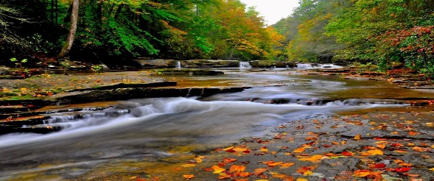
Shillala Creek
Phone: 606-248-2482
Website: http://www.bellcountytourism.com
Description: This stream is one of two streams in the state with wild brook trout. Steep in elevation and thick with mountain laurel and hemlock, it is a challenging yet beautifully regarding place to fly fish for brookies. This is blue-lining in Appalachia at its best. It is located in Shillala Creek WMA with parking on the side of Hwy 217 just beyond the Hwy 1344 intersection.

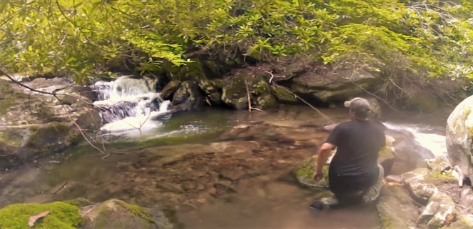
Cannon Creek Lake
Phone: (606) 248-2482
Website: www.bellcountytourism.com
Description: This 250-acre impoundment in central Bell County is a phenomenal fishery for largemouth, smallmouth, and Kentucky bass as well as trout, bluegill, crappie and catfish. There are no gas-powered motors allowed on the lake, making it ideal for kayakers. There is access to a boat ramp on Cannon Creek Rd which is located in the Meldrum Community, with access from Old Pineville Pike.
Kentucky Ridge State Forest
Phone: (502)-564-4496
Website: http://forestry.ky.gov/Kentuckysstateforests/Pages/KentuckyRidgeStateForest.aspx
Description: This 15,000-acre jewel is located in central Bell County between the cities of Pineville and Middlesboro with access on Hwy 190. It is bordered by Corrigan Wildlife Management area on its southern border. It is dually managed by the Kentucky Division of Forestry and the Kentucky Department of Fish and Wildlife. It is open to not only hunting and fishing, but also horseback riding and primitive camping.
Wildlife Management Areas
Phone: 800-858-1549
Website: http://fw.ky.gov or www.bellcountytourism.com/attractions
Description: Bell County is home to seven WMAs totaling over 100,000 acres of public hunting. These include Corrigan WMA, Shillalah Creek WMA, Asher Hunter Access Area, Kentucky Ridge State Forest WMA, Elk Forest WMA, Fortner Davis WMA, and Boone Forestlands WMA. These WMAs have white-tail deer, elk, turkey, bear, and much more. A lot of these are in designated elk zones, and Bell County is also one of only four counties in the state to have black bear season. For info on each individual WMA (including maps), please visit www.bellcountytourism.com/attractions
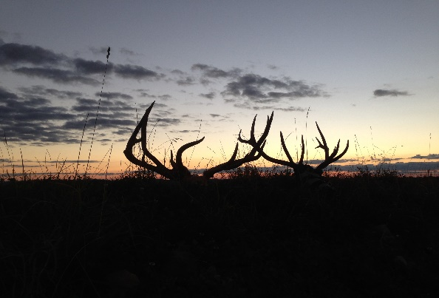
GOLF COURSES
Middlesboro Country Club (9 Hole)
Location: 155 Country Club Ln / Middlesboro, KY 40965
Phone: (606) 248-7435
Website: www.middlesborocountryclub.com
Description: Middlesboro is home to the oldest continually played golf course in America. It was founded in 1889, the same year as the town, as a way for the English investors and businessmen who were settling in the area to have some recreation. Nestled inside a beautiful circular valley, the golf course was proven to be the center of impact for the meteor that created the unique valley that the city of Middlesboro sits in.
Wasioto Winds Golf Course (18 Hole)
Phone: 1-800-814-8002
Website: http://parks.ky.gov/golf/18_hole/pine-mountain/
Description: This 18-hole golf course is nestled in shadows of Pine Mountain and offers one of the most spectacular back drops for a game of golf that you can find anywhere in the nation. This eighteen-hole course includes five par 3 holes and five par 5s. True to its links nature, the course is relatively flat, with water coming into play from three lakes, a creek and several wetlands areas. Six arching bridges span the water throughout the course. Other course features include wide car paths, a practice range, and two practice putting greens.
INDOOR ATTRACTIONS
Bell Theater
Phone: 606-499-0660 or 606-337-2958
Website: https://www.facebook.com/Bell-Theater-125134245078/
Description: The newly renovated, 200+ seat Bell Theater in Pineville features events of all kinds, from movies to plays to concerts. For upcoming events, please check their Facebook page linked above.
Bell County Historical Society
Phone: (606) 242-0005
Website: www.bellcountyhistorical.com
Description: The Bell County Historical Society is located right beside the Middlesboro Post Office on 20th St. It houses many artifacts and exhibits pertaining to the county’s history including the Middlesboro meteor crash, coal mining, Indian artifacts, and much more! Hours and info are on website.
Alexander Arthur Museum
Phone: (606) 248-2482
Website: www.bellcountytourism.com
Description: The Alexander Arthur Building and Museum is located at 2515 Cumberland Ave in Middlesboro and is home the Bell County Tourism office. It also has a small museum with items concerning the founding family of Middlesboro.
Abraham Lincoln Museum
Phone: (423) 869-6235
Website: http://museum.lmunet.edu
Description: This museum has a fantastic collection of Abraham Lincoln artifacts and memorabilia. It is located on Hwy 25E in Harrogate TN on the campus of Lincoln Memorial University.
INDOOR ATTRACTIONS, con…
Skate World
Phone: (606) 248-0219
Website: http://skateworldky.com/
Description: Skate World is located on Cumberland Avenue in Middlesboro, KY. This iconic Middlesboro roller skating establishment has been around for decades. Skate World accommodates parties and church groups as well as individual skaters as well. There is also a pro shop within the facility as well. Check the website for prices, hours, and more info!
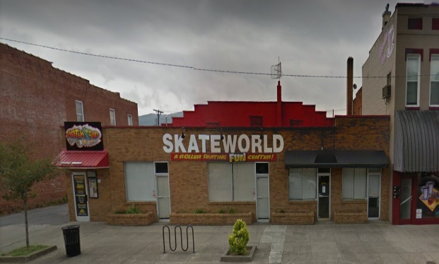
Golden Ticket Theater
Phone: (606) 248-0426
Website: https://www.gtcinemas.com/
Description: G olden Ticket visitors a four-cinema theater in the Middlesboro Mall. Located just beside HeHuDarz Laser Tag. Visit website for movies currently playing, show-times, etc.
Hillcrest Lanes Bowling and More (Harrogate, TN)
Phone: (423) 869-4120
Website: https://www.facebook.com/HillcrestLanesBowlingCenter/
Description: Featuring 20 Lanes of Bowling, League Bowling, Pool Tables & Arcade Game Room. We have discounted information for Birthday Parties & Church Groups. Also, if interested in joining and/or being part of a bowling league team, call or come by.
Laser One Arcade
Phone: (606) 248-0455
Website: http://www.shopmiddlesboromall.com/
Description: Laser One is an arcade facility located within Middlesboro Mall. We feature a full gallery of amazing arcade games in a family friendly environment. We are located in the old Aladdin’s Castle location across from the movie theater.
LODGING
Elk Creek Cottage
208 Arthur Heights / Middlesboro, KY 40965
(606) 269-2993
Website: www.elkcreekcottage.com

Pine Mountain State Park Lodge
U.S. Highway 25E / Pineville, KY 40977
(606) 337-3066
Website: http://www.state.ky.us/agencies/parks/i75frames/pinemtn2-body.htm
Boone Trail Inn
2105 US Highway 25 E / Middlesboro, KY 40965
(606) 248 - 1340
Website: http://boonetrailinn.com/index.php
Sleep Inn & Suites
1260 N 12th Street - Middlesboro, KY 40965
(606) 576-7829
Website: http://www.sleepinn.com/hotel-middlesboro-kentucky-KY217?promo=gsiky217
Holiday Inn Express
1252 N 12 St / Middlesboro, KY 40965
(606) 248-6860
Website: http://www.ihg.com/holidayinnexpress/hotels/us/en/middlesboro/kymid/hoteldetail
Econolodge
1623 Cumberland Avenue / Middlesboro, KY 40965
(866)599-6674
Website: https://www.choicehotels.com/kentucky/middlesboro/econo-lodge-hotels/ky363?mc=llgoxxpx
RESTAURANTS
Middlesboro
La Esperanza (2 Locations), Pelanchos, Hiro Habachi, Ikes Artisan Pizza, Shades of Brown, Bubby’s BBQ, King Buffett, Cracker Barrel, Chinatown Café, Arby's, Burger King, Conley's Drive In, Dairy Queen, Hardee's, KFC, Kyrstals, Lee's Famous Recipe, Long John Silvers, McDonald's, Papa John's Pizza, Pizza Hut, Pizza Plus, Sonic, Subway, Taco Bell, Taco Casa, Tasty Time, Yamato’s Japanese Steakhouse, Waffle King, and Wendy's
Pineville
Sauced Pizza, The Butchers Pub, Mountain View Restaurant (Pine Mtn State Park), Leonz Steak and Subs, House of Shenanigans, La Esperanza, Dairy Queen, Engle's, KFC, McDonald's, Pizza Hut, Subway

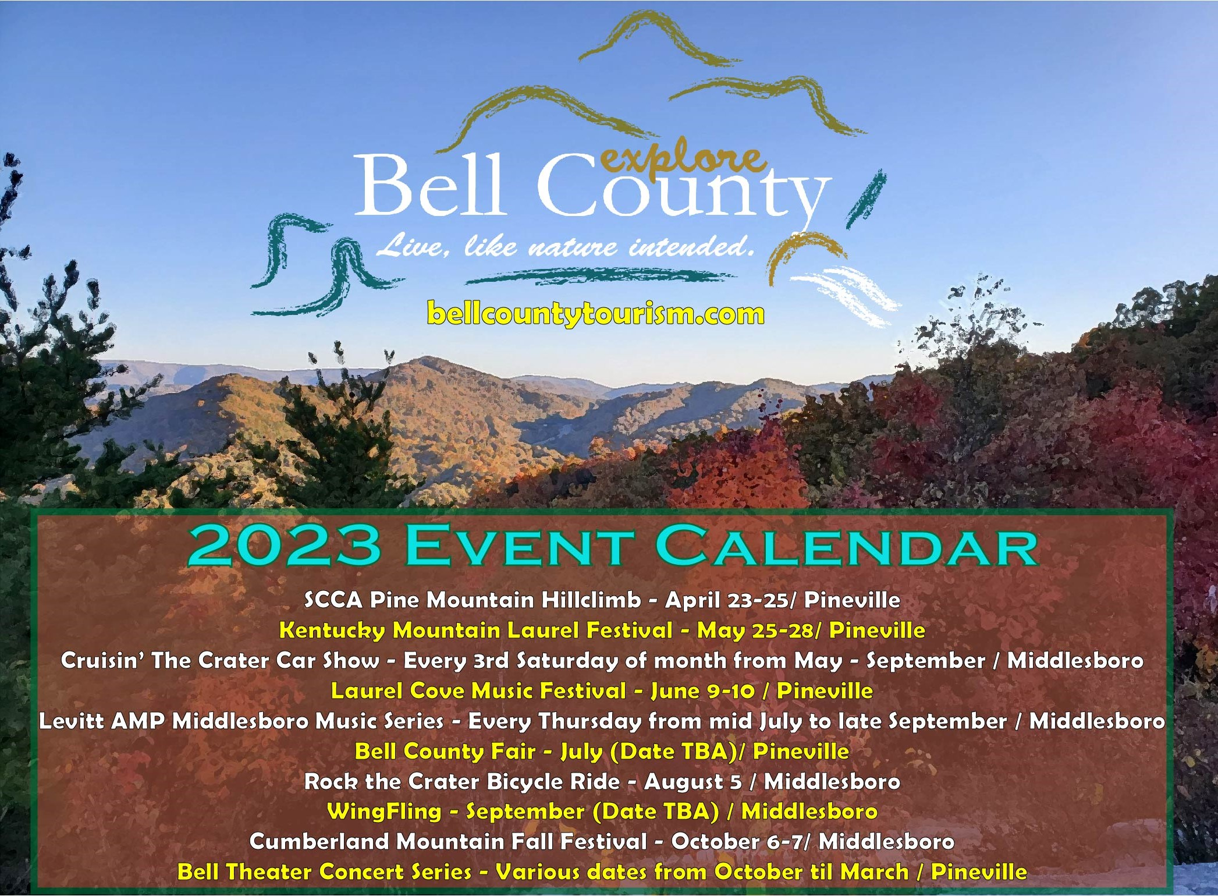

For more events, check out our Facebook page at www.facebook.com/BellCountyKYTourism

Coming in early 2024 – Boone’s Ridge! This attraction will showcase local wildlife, history, and culture in a state-of-the-art facility that is estimated to draw over 800,000 people a year! Visit www.boonesridge.com for updated information.
